Table of Contents
- Introduction
- Module 1: Why PLCs?
- Module 2: Structures of PLCs

- Module 3: Building Effective PLC Teams

- Module 4: The Practice of PLCs – Part 2
- Essential Questions, Objectives, & Vocabulary – 2
- Introduction – 4
- Collaboratively Approaching Dilemmas – 4
- Consultancy Protocol Case Study – 5
- Protocols for Dilemmas – 6
- Creating and Action Planning from Common Assessments – 7
- Peer Observations, Protocols, and Case Study – 9
- Data Teams in Professional Learning Communities – 15
- Mass. Educator Evaluation in Professional Learning Communities – 16
- District Determined Measures and Common Assessment – 17
- Next Steps – 18
- Tools and Resources – 20

- Module 5: District-Level PLCs
- Tools and Resources
- Facilitators Guides
Module 4: The Work of PLC Teams – Part Two

Essential Questions
- What do PLC Teams do?

- How does the work of a PLC connect to what we are already doing?

- How do we use the structures and habits of PLC as the lens to connect that work to our larger goals?

Expected Outcomes
Participants will:
- Be able to begin using practices of an effective PLC

- Identify how collaborative analysis of day-to-day classroom data like student and teacher work is a key practice to improving teaching and learning.

- Understand how other data-related practices connect to the work of PLC

Vocabulary
- Common Assessments – are created by vertical or grade level teams as action plan benchmarks to assess student learning in areas specific to team goals

- Clarifying Questions – Questions that need to be answered in order to clearly understand what one is being asked to do. Clarifying questions are often formulated by individuals who really want to understand what kind of feedback they are being asked to provide for a colleague. Clarifying questions are not judgmental or evaluative in nature.

- Probing Questions – Questions that attempt to "push" a conversation deeper, add to, or challenge ideas being considered are probing questions. They are often used to explore the underlying assumptions of a particular argument or line of thought.

- Learning Walkthroughs – A highly- structured process for brief team visits within the school to collect evidence which can result in identifying successes and challenges.

- SMART Goals – The MA Educator Evaluation regulations require educators to develop goals that are specific, actionable and measurable. They require, too, that goals be accompanied by action plans with benchmarks to assess progress.

- Data – Any source of information which can be collected to help provide a picture of teaching and learning: student and teacher work, student test scores, school and district assessments, attendance, discipline are just a few of many resources which can be used as data.

- Data-Based Inquiry – A deliberative process in which teachers, administrators, and other relevant stakeholders collect, examine, and analyze a range of data relating to problems and challenges that a school or district face, and develop action plans to address them.

- Data Teams a– help a district or school to establish, grow, and maintain a culture of inquiry and data use that can inform decisions that impact teaching and learning, and ultimately improve the achievement of all students.
Introduction

In Part One, we introduced Looking at Student Work and building a culture of critically supportive feedback that results in an informed change in teaching and learning. Moving that practice one critical step farther, is when PLCs build on the work of creating trust with process and norms, and focus on big questions about what really happens in the classroom, with non-evaluative peer observation. Effective PLCs are always questioning the teaching and learning practices of their schools, and make effective use of various types of data to inform any proposed changes to move the work forward.

Collaboratively Approaching Dilemmas

What are we doing? Why are we doing it?
Is this reflective of what we know about student learning?
What do we do when our students aren’t learning?

The basic format for collegial dialogue is the same for each protocol: facilitator overview; presentation of observations, work or issue; clarification questions; feedback/discussion by participants (discussants); presenter reflection; debriefing of process. The questions and issues that presenters offer typically spring from feelings of concern, from moments in work without closure, and from issues they have not been able to find a solution through solitary thinking.

We are always running into dilemmas in our teaching but we might not have a school culture for approaching their resolution in a positive, collaborative manner. If we have a student who is a challenge, we are more likely to look for support in how difficult the student is rather than step back and look at the situation from a longer view.

We also deal a lot with the practical “stuff” of educating students: field trips, scheduling, materials, and other day to day challenges. Using the process of Inquiry Cycle as a way to process collegial dialogue is often a very efficient and satisfactory use of time, which keeps us focused on what our real questions are, and how they connect to student learning?

Anything that a teacher has a question about in her practice is food for a dilemma protocol where challenging teaching situations can be shared, explored and potentially improved. Where once we might have had a quick conversation during hall duty or devoted what might have been not-very-productive conversational time in team or faculty meeting can often be resolved or informed by using a structured protocol.

While dilemmas can be looked at via peer observation, content protocols or other structured setting, we often use a Consultancy Protocol which mirrors the practice of deep listening used in therapeutic settings—but it’s not therapy! This protocol is used widely in business and medicine as well as in education. The process is friendly and thoughtful but can involve some hard questions (if the question was easy it wouldn’t need a protocol). The goal is to drive the thinking of the presenter deeper and not to solve the person’s dilemma (as in “I think he should…”).

There a number of consultancy protocols (see Tools) which generally use a process of asking the presenter to share his question, speak shortly about the dilemma, answer clarifying (brief and simple yes/no) and probing questions (which require thought and are often more complex) and then “listen” and take notes as the group talks among one another about what they heard and thinking about “I wonder if he had considered…” possibilities. And of course—using these protocols requires Trust (capital T) and strong facilitation as teachers often have the need to move forward and solve the issue for the presenter the way they would!

One caution for all protocols that involve teacher –as- learner is that none of them are effective if the presenter is not truly willing to change his practice to accommodate new ideas. It is critical to explore this with each team or group before beginning to use Consultancy Protocols—and it’s okay for the presenter to kindly acknowledge that in fact he appreciated being able to supportively air his concern but he has yet to learn something that he felt would be beneficial to his dilemma.

Consultancy Protocol Case Study
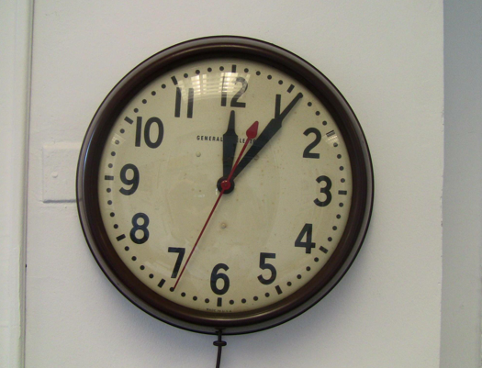
It was the second in a series of Pilot PLC Institutes when Paul asked to present in the afternoon’s Consultancy Protocol (where members practiced facilitating protocols) around his school’s challenge in finding time for collaborative teams to meet. His question resonated for a number of participants and he had quite a crew enthusiastically ready to explore it.
Maura, the facilitator, met briefly with Paul and asked him to write about his dilemma. After sharing his writing they identified his question and decided on the appropriate protocol. Paul felt his query was pretty simple, “How can our school make time in our schedule for teams to meet regularly?” which was a question that resonated for a number of schools at the Institute.
Maura asked Paul to present his question and the 45 minutes flew by with Paul taking notes fast and furiously as the group went over what they had heard. The final segment offered insights like:

“I heard Paul say that departmental meetings are usually times where information is shared but there is no real action plan.”
“I wonder if Paul’s school has considered changing how they rotate days in their schedule which might open up some common time”

When Paul rejoined the group and shared his reflections on what HE had heard, he realized that some of the possibilities to his school’s time dilemmas, which he had explored in his own responses to clarifying and probing questions as he thought more deeply about it and had been built on by the group, might in fact be real solutions. During the debrief when group members reflected on the protocol process, Maura acknowledged that she had to closely facilitate when probing questions were offered as solutions rather than to help push Paul’s thinking and hoped it had been okay when she stepped in to remind members. Paul commented that the process was the antithesis to how his school had been approaching the question of time, as they used a lot of it talking about what they couldn’t do rather than looking positively at what they could. Group members left eager to take this structure (and the same question!) back to their schools to share.

Additional protocols that can be helpful in building professional collaborative cultures can be found in the Tools section of this module. Some examples are:

Protocols for Dilemmas:

Name of Protocol When To Use It What To Bring
Issaquah Protocol | When a group or individual has a dilemma that she/they feel is important and about which she/they is/are willing to make a change in practice. | Written detailed copy of the dilemma.
Consultancy Protocol | To get feedback on a question or concerns regarding certain aspects of student or teacher work. | Written reflection by presenter. A question to focus feedback. Student work that illustrates the question or concern.
Tuning Protocol | To develop more effective curriculum plans, assignments, or assessments. To develop common standards or assessments for students’ work. To reflect on and gather ideas for envision of classroom practice. | The assignment , lesson, project in process or before it is given to students.  Student work at any stage which reflects the assignment.
Charrette Protocol | To get feedback on a process or piece of work when the teacher, student, or group is experiencing difficulty, or when additional minds could help move it forward if the presenters feel “stuck”. | Any work “in process”
Critical Incident Protocol | Teacher reflects with colleagues on a particularly significant or compelling incident from his or her work in order to gain new insight. | A written piece by the presenter that tells about the incident in detail
The Slice Protocol | To learn from student work or assignments by looking at cross-section of student responses to the same assignment or several pieces of work from a single student in one class or several. | Common benchmark assessments, homework or in-class work assigned by all members of a team to the same student or a cross-section of students. Teacher assignments from the same team or discipline.
Description of a Child | Presenter discusses a student about whom she has a question or dilemma in this facilitated protocol which emphasizes who the student is and what her strengths are. | Any data pertinent to the student: examples of student work, assessment data, school records, health records

Tips for Facilitating Consultancy Dilemma Protocols

- Clarifying questions are simply to set the scene (“How big a class is it?”) and usually require short answers or yes or no. When clarifying questions start to go deeper, it’s time to move on to Probing Questions.

- Probing questions ask for deeper thought and are harder to answer. These are usually where the real learning for the participant is done as they help to really get to the root of the dilemma.

- Check in with the presenter before the session about whether her dilemma is still pertinent. If she has solved the problem or has a good idea now of what she might do—she no longer will benefit from a consultancy on that question.

- Be clear with participants when they move into “She should” reflections in the discussion by reminding them that the goal of the consultancy is not to solve the problem but to deepen the presenter’s thinking.

- Plan the time closely, giving the benefit of it to probing questions, discussion and participant reflection.

- During the closure of the protocol, check in with the presenter to see if she might need further resources or support and check back again with the next agenda to see if the dilemma has been resolved or still needs addressing.

- Don’t forget the debrief!

Common Assessments
While PLC teams will use formal standardized assessments to see where their students are across district, state and federal standards, they will also want to regularly use a smaller common assessment which they have created or chosen themselves as being reflective of what they are teaching. These can be used across a grade, content area or in looking at spiraled skills and knowledge vertically. They might be paper and pencil but they often include performances, exhibitions, or projects which are created from a common rubric of excellence in terms of what students should demonstrate regarding knowing and understanding.

The assessment does not need to be large but it needs to be authentic: created or chosen by all members of a team who will be implementing it and assessing the results. Using a protocol to look collaboratively at the student work yields data which will likely inform the team’s action plan benchmarking (“Where are we in working towards our goal of all 9th grade math students being able to master solving linear equations?”) and informs next steps. These steps might lead back to looking at student and teacher work, thinking through focused, supportive professional development, peer observations and using dilemma protocols to identify ways out of places where a teacher might feel “stuck” in finding ways to provide the same success to all students.

Schools might also intersperse using Looking at Student Work “Slice Protocols” to gather snapshot data about student learning. Typically these are examples of student work but can also be teacher work (lesson plans, assessments etc.). A “slice” work is collected during a particular time frame, and the protocol helps the team to examine the work, to look at what questions it raises and to use that as data for their action planning.
The process might look like this:

- When creating the year’s team action plan, identify when, where and what benchmarks will be used to help the team assess progress. These are important to the success of any action plan and can inform the team about where there is success, where there are challenges and whether the plan needs to be altered.
- After identifying the benchmarks, the team decides what criteria are of value in creating a common assessment that will inform them about student learning at this exact point in time. They also create a rubric (See Cookie Monster Protocol in Module 4 Tools)
- A collaboratively created or agreed upon tool is designed and team members agree to use it at the same juncture in the year.
- The student work is shared at a team meeting and a protocol and rubric are used to assess each piece of student work. (See QPA Calibration Protocol or LASW Protocols in Module 4 Tools)
- The results and overarching learnings from this are used to re-visit the team’s Action Plan for the year, changes made, or successes celebrated. Action steps may include further teacher collaborative support in helping team members share competencies so that all students have an equitable and effective learning experience.

Peer Observations
How are we teaching it? How do we know our students are “getting” it?
How do our students know they are “getting” it?

Peer observation is another powerful tool of a professional learning community. In peer observation, teachers observe their colleagues in a structured, supportive way in order to improve student learning. When teachers teach in isolated classrooms, there is little opportunity to get feedback on how we are doing or to learn from each other. Without the stimulation that comes with such collegial discourse, many teachers stick with the lessons and instructional techniques they are familiar with. Lacking an ongoing infusion of new ideas and support from colleagues, many teachers become dispirited and frustrated when their students don’t make progress.

Historically many teachers have only experienced peer observation as an evaluative measure done contractually and in many cases infrequently. The scheduled visit from the superintendent or principal often meant showcasing sure-fire best work.

Collegial peer observation is non-evaluative. Just as teachers need to take care in how they give feedback to colleagues while working and when using protocols for looking at student and teacher work, they also need to develop similar skills for peer observation. Before engaging in peer observation protocols, teachers should be familiar with their different purposes and processes. They should also be aware of and have practice in using the essential skills of active listening and observing, using descriptive rather than evaluative language, and moving from positive to challenging comments. Peer observation is a collaborative process in which teachers observe and are observed by each other in order to improve their practice. The focus of the observations is driven by teacher-questions and not by school or district demand.
Peer observation requires trust. Getting feedback on a difficult question a teacher has about her practice means knowing that what she asks for in terms of colleague visits will be held to the terms of the protocol they have decided on. That means confidence in how reflective feedback is shared, and in confidentiality. Creating a culture that honors these tenets is part of the primary work done by PLC teams.

Peer observation can help teachers become more effective as practitioners, thereby increasing job satisfaction and improving student achievement. Schools are broadening the definition of professional development to include more flexible approaches to building staff knowledge and skills, and many are using peer observation as part of a comprehensive professional development plan. Once teachers have identified their S.M.A.R.T goals and subsequent questions that arise from getting there, non-evaluative peer -to -peer observation is often a very useful and welcome part of a personal or team action plan.

Peer Observation Protocols

Name of Protocol When to use it What to bring
Ghost Walk  Protocol | Use as a way to assess school climate and culture, this protocol addresses how the building “feels” and “looks like” in relation to a focus area of concern. | Ghost Walk happens with a small group using a focused question—(Tone of Decency” “Personalization” etc. when classes are not in session—
Focus Point | This protocol is designed to help deepen the teacher’s understanding of the effect of his/her practice on students. Use it when you want an observer to look at just one or two specific areas of concern you have identified for an observer to pay attention to –e.g. “How well do I explain directions to my students? Do they get it?” | Pre-session between observer and teacher creates and defines the focus question and how closely the teacher wants the observer to delve into the focus (e.g. is it okay for observer to talk with my students to check in for their understanding or feedback?”  Post-session is ONLY about sharing what was asked for in the Focus Point question.
Video Camera | No two sets of eyes and ears see and hear the same thing the same way. Use this when you want the visitor to observe your classroom like a video camera—looking at as many events going on as possible and reporting back as evidence, not assumption. | It is important that both parties refrain from interpretation. To say that the student was bored is very different from saying that the student drew circles and designs in the margins of papers, yawned, and looked out the window. Value statements (such as, “That was a great lesson”) should also be avoided.
Observer as  Learner | An unstructured protocol this is completely for the observer’s benefit to learn from the observed teacher. It helps to define what the observer is looking for but the goal is all about what she will take away that will help improve her own practice. | This protocol can be used when a high level of trust is in place and both observer and observed feel completely comfortable with visits.  A pre-conference and a post-conference are helpful for both parties.

Peer Observation Case Study
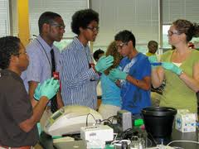
Science teacher Melanie Turner came to her grade level PLC Team with a problem. She watched her tenth-graders as they worked together on group projects. Although she always had a balance of diverse students in these cooperative learning groups and switched group roles for each new project, the groups always resorted to the same pattern, in which the strong, outgoing students took over. She wondered if she were doing something wrong and if there was some way she could better facilitate this process. Her colleague David, who taught social studies, discovered that he had a planning time that would allow him to visit Melanie’s classroom to work with her using a peer observation protocol that would allow her to be able to “see” and “hear” what was happening in group dynamics. Melanie felt comfortable having David in her classroom and knew she could trust his level of objectivity.
Having fine-tuned what she wanted David to look for, she and David chose the Focus Point protocol as most appropriate to Melanie’s crafted question. She asked him to look at what the students were doing and saying in their groups and how she interacted (or didn’t) with them. These were the only areas David would observe and record. Melanie asked him to be an active observer, walking around the room and sitting near groups. Since the team frequently visited one another’s classes, the students were unlikely to find David’s presence odd. Finally they reviewed the norms they both needed to have in place for this to be a productive experience.
Soon after his visit, David and Melanie sat down and shared what David had observed—just the evidence, “This is what I heard, this is what I saw.” He did not say, “This is what I think.” Melanie decided to bring her new questions gleaned from David’s observations back to the team and look for their support in helping her to reflect on what she wanted to see happen in her class, and plan how to get there.

While some schools and districts may have adopted some regimens for peer observation that are characterized by first defining excellence (“This is how it should look”) in teacher practice and then requesting that other teachers come observe in order to replicate the practice, our definition of peer observation is more far-reaching. Peer observation which uses specific protocols are completely driven by what the teacher’s question is about his practice. Success is determined by how that teacher or team identified it as part of an action plan that originated from using a Cycle of Inquiry which utilized that question to drive a series of actions.

Peer Observation Cycle of Inquiry

- Getting Ready/Organizing for success: Have the structure available that allows for peer observation time—all three phases; Pre-conference, visit, post-conference and review what needs to be in place for the visit to be of professional use. Peer observations need to be tied to inquiry that drives real change of practice, not just, “Oh, that was great, thanks.”

- Inquiry/Ask the right questions: The teacher with a question will want to work with her team or invited observer to formulate the question she feels best drives her query. This question may change during the process—be open to that as the presenter learns more about the situation. Most protocols used in PLC give time to reviewing the driving question—and reviewing.

- Information/Collect and analyze data to help us answer those questions. The data is in the observation. The observer though, sticks strictly to what the observed teacher and the protocol request—nothing more/nothing less/, and presents those findings as data for the observed teacher’s use only.

- Knowledge/ Use current research and shared experience to make sense of the data: After (or during) the debrief part of the protocol, the presenter may have new questions (and often does! That requires more information. Colleagues at a team meeting may be helpful or specific channels of resource may be suggested, some of which may benefit from in-house professional expertise (“You know I visited Mr. Barrientos’ class and noticed he was doing a very focused job of dealing with a similar situation”) or other observation.

- Action/ Apply that meaning to create action steps to improve teaching and learning: The data that comes from the non-evaluative peer observation should inform the observed teacher’s question and help her to create an action plan of next steps. If her question is still accurate and she has identified what success looks like, then her observer or her team can help her to create a time-based, bench-marked action plan of specific steps she feels will help her to resolve her dilemma.
“Teachers need to analyze and reflect on their practice, assess the effect of their teaching, and then refine and improve their instruction.”

-L. Darling-Hammond Teaching for Intelligence, 2nd edition, Corwin Press 2008.

- Results/Increased student learning: Peer observations conducted in a culture of shared trust and meaningful interactions have an enormous capacity to change teacher practice.

Tips for Facilitating Peer Observations

- Take the time to be sure there is trust between presenter and observer.

- Choose a peer observation protocol that both address the presenter’s question and meets his level of trust. For example, the Focus Point Protocol asks the observer to ONLY actively observe one aspect of what’s going on during the lesson (e.g. “Do I connect with every learner in the classroom at least once during the class?) and does not mean during the debrief, “Oh and I also noticed that…”

- During the debrief ask the presenter to think about what she learned from the data shared, how that informs her practice and if that creates a goal—and action plan to get there.

- It can be really helpful to do a few “practice” protocols by watching a video of a class in session. Everyone can be an observer with the debrief serving as a forum for comparing experiences and further clarifying the process.
________________________________________________________________

Connecting Looking at Student and Teacher Work and Peer Observation to Learning Walkthroughs

Learning Walkthroughs can either provide data about what is going well or raise questions about areas of concern. Using the ESE protocol developed in the field by DSAC coaches, this practice dovetails well with the work of a PLC. Learning Walkthroughs can, like peer observation, be a way of exploring areas of challenge (and success) and are, like looking at student work, a window into the classroom.

Once school teams have decided what their question is (Focus of Inquiry) for a well-planned Learning Walkthrough and gathered the resulting data (“What did we see? What did we hear? What questions do we have now?”), they usually find either they have more questions or they are clear about a desired goal centered on how (or what) students are learning and how (or what) teachers are teaching. An action plan is part of the PLC team work.

Through engaging in the process of Learning Walkthroughs, educators can:

- Create of a culture of inquiry and research, characterized by collaborative learning and reflective practice;
- Enhance focus on classroom practices, instruction, and student learning experiences;
- Enhance professional dialogue about teaching and learning among district leaders, school administrators, instructional coaches, and teachers;
- Develop a common language about teaching and learning;
- Improve district and school infrastructures to support teachers;
- Identify opportunities for additional coaching and professional development;
- Creation of more consistent and higher-quality teaching and learning experiences throughout the school and district;
- Gather data to inform a Conditions for School Effectiveness (CSE) self-assessment;
- Observe classroom practices that inform conversations of PLCs.

The Learning Walkthrough process differs from traditional classroom visits in a number of ways. The following are important characteristics of this process:
- A Focus of Inquiry frames the classroom visits, dictating the types of evidence that will and will not be captured. This Focus is established by leadership and interested educators prior to attending to the logistics of the Learning Walkthrough. Data and prior first-hand experience in classrooms inform the Focus, ensuring that the Learning Walkthrough will result in information centered on key, high- leverage areas for improvement. Objectives and specific evidence of classroom interactions is scripted. Learning Walkthrough team members discuss the trends suggested by the evidence in relationship to a broader vision of effective standards-based practice, identifying strengths and needs in the current level of practice.

- Aggregated evidence from multiple classrooms over a brief period of time provides a snapshot of instructional practices within a school.

- Deep discussion and analysis of aggregated evidence is used to identify school-wide challenges and accomplishments. This information then informs both short- and long-term actions related to the School or District Improvement Plans.

When Learning Walkthroughs are embraced as a method of gathering evidence, enriching discussion, and promoting inquiry and continuous improvement, they can have a significant impact on professional culture, and school and district improvement.
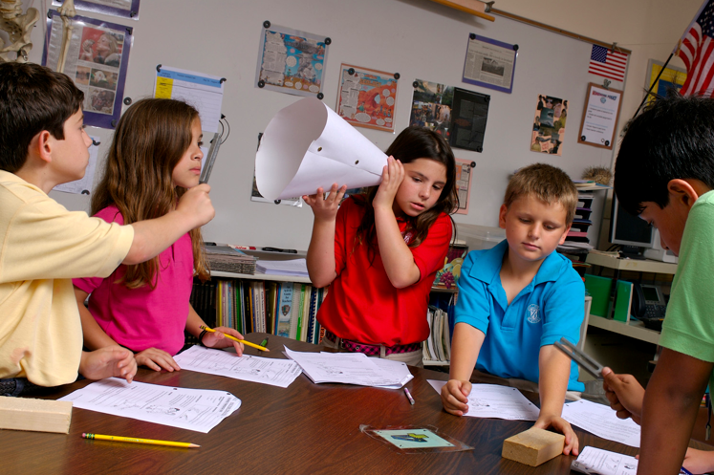
Rather than just wait until the next Learning Walkthrough and hoping things have changed without having a chance to really SEE progress (as in “let’s get some PD and hope that works”) Looking at Student and Teacher Work and non-evaluative Peer Observation can both provide more data (information) about the question that arose from the Learning Walkthrough as well as benchmark progress.

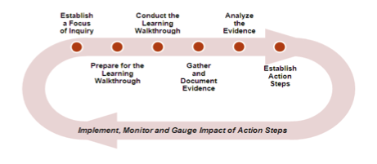

_______________________________________________________________

Data Teams in Professional Learning Communities
What are we teaching?
How do we know if our students are learning?

Many schools and districts in Massachusetts have formed Data Teams who are representative of schools and grade levels across the district and who become well-versed in looking at data. Determining where there are gaps in student achievement is a first step (mandated assessments, common assessments, district assessments etc.). Determining contributing factors (attendance, discipline, grades, promotion, language, , social issues, learner disabilities etc.) is the second. Here in Massachusetts we encourage districts to use the orchestrated Data Team Tool Kit from the Department of Education to structure these conversations.
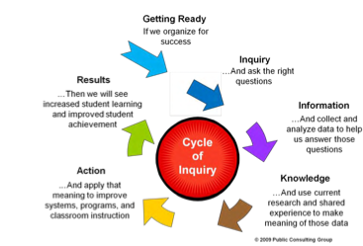

The District Data Team Tool Kit uses the Cycle of Inquiry to identify successes and challenges, create goals and structure action plans. The Toolkit is designed for district-level staff, to promote the skills and knowledge necessary to build their capacity to effectively use inquiry and data to inform district-level decisions. As a District Data Team gains comfort with the tools, resources, and processes in the Toolkit, it can plan ways to share them with school-and teacher-level data teams who in turn inform teachers. All faculty though, should know how to access DOE student District Analysis and Review Tools (DART) where student data is broken down into subsets and how to understand it as it relates to equity and student learning.

Teacher teams at the school level use data to inform their work as well, and many of the tools in the District Data Team Tool Kit are applicable to team use as well. In some instances teachers have remarked that while they have spent time “looking” at data in their school (usually standardized scores) they are not as familiar with how to apply what they find to a change in practice, nor do they have much opportunity to look at specific school data that goes beyond testing.

Student Work as data is one of the best barometers of student learning and one that naturally leads into looking teacher practice. Additionally teachers will want to look at their grade books, student discipline, attendance, home-school family connections and…

“What modalities do I tend to teach to?”

“What do my students’ grades look like on specific assignments?”

Who doesn’t do homework and who does –why? Is the homework I assign helpful?”

“Who is in class every day—and who isn’t?”

“Do my assignments vary in terms of expectation between classes and students?”

“How do I diversify assignments without sacrificing high expectations or high levels of learning and engagement?”

______________________________________________________________________

Massachusetts Educator Evaluation in Professional Learning Communities

Smart Goals
One opportunity for teachers engaged in trusting relationships is the shared development, implementation, and monitoring of teacher SMART Goals.

These professional goals require identification of challenges in practice and action planning.

PLC Teams use Looking at Student and Teacher Work and the analysis of many other sources of student data to identify areas of challenge and to create team and teacher goals. Having access to non-evaluative Peer Observation from colleagues using structured and focused protocols brings these goals to meaningful purpose. PLC Teams epitomize the work of “collaborative and continuous learning.”

The implementation of PLC in schools introducing the MA Educator Evaluation System can move evaluation concerns into a climate of using evaluative goals as embedded practice in non-evaluative collaborative learning and practice.

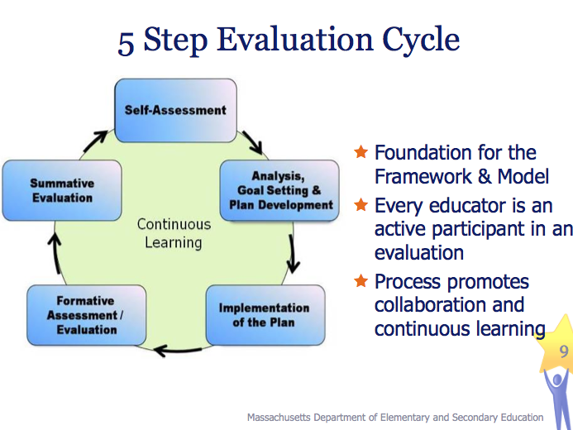

________________________________________________________

District Determined Measures and Common Assessment

What are we teaching?
How do we know if our students are learning?

With a goal of providing excellence to students in all classrooms where each is taught a strong and engaging curriculum, Common Assessments are a true barometer of what it means to de-privatize teacher practice. If everyone teaching the same subject to the same grade level students agrees on what students should know and be able to do, this is an invaluable resource for understanding, Common Assessments created by the teachers who are responsible for student learning across a content, skill or grade level are a critical part of the work of PLCs. Substantially different from state assessments, they may be used only for data and do not have to be a graded assessments. Common Assessments are created by teachers as a way of knowing what they are teaching and whether the students are “getting it”. They open the door to collaborative conversation and lead right back to Action Planning, Looking at Student Work and Peer Observation.
“Once the assessments are completed our math teachers gather to review their student results together. The meetings are carefully facilitated to ensure a safe place to share challenges as well successes. By making their student results public to their colleagues, the level of accountability to improve their practice rises dramatically; no one likes to be perceived as ineffective. The culture of the group is supportive but also urgent in suggesting changes of practice. Teachers are becoming accountable to each other in service of their students learning without any external system driving their work.”
Bob Lenz Edutopia
_______________________________________________________
Case Study

- Consultancy Protocol in Action: What does it actually LOOK like when you do a collaborative dilemma protocol? A fourth grade team clip using a Consultancy Protocol 15 minutes.

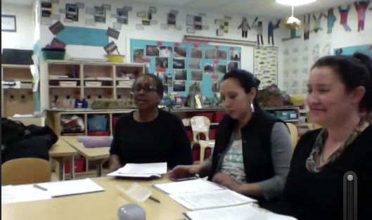

___________________________________________________________

Next Steps for deepening the work of PLC:

- Like everything else in your work as a PLC—build trust. If there has been a breach of trust seems fragile, go back and explore together what the group needs in place to ensure it. Deepening the nature of the work in peer observations and looking at dilemmas means deepening the nature of that trust.

- Read, talk and problem-solve. Take the time to review together in text-based discussions, new protocols as well as the variety of supportive documents included in the Tools section of this module. Participants need to know and understand why and how. There are several videos that can provide rich discussion—what did we see? Hear? What questions do we have? What more do we need to know?

- Practice peer observation using videos of classes and “fictional” scenarios for dilemmas.

- Be very clear at the beginning of any of this work about where the information goes—and how it is used, especially if administrators are part of the process (as they should be!). Some of the work a PLC engages in IS (or could be) part of teacher and school evaluation and while that changes the nature the conversation, it shouldn’t change the outcome—action inquiry planning.

- If you have developed a good foundation in previous PLC work, don’t be afraid to jump in and start working with dilemmas. Let people volunteer to present while and ensure that the facilitator has a strong sense of what she is doing or has a co-facilitator for support. It’s fine to step in and out of the facilitator role to share what you are doing or to ask for help. If a member of the group does not step up to share at some point, then it’s a dilemma and treat it as one.

- Make a plan. We introduced steps in using protocols very purposefully. While your school may do very well with diving right into peer observations, it’s what comes out of those that make change. Looking at Student Work is a door-opener, be thoughtful about how fast you swing it open! Think about using the 4 Corners activity and the facilitation scenarios to provide collective experience with the Inquiry Action Cycle.

- Make a Big Picture—now that you have all these tools at your fingertips, how will they support your school goals? How can they help you identify challenges, goals and benchmarks?

- Share your progress. If teams are meeting independently they will all be moving at different rates. How will they share what they are doing? How will they support each other? How will they measure success? Consider creating opportunities for group facilitators to meet and share.

Tools & Resources – The Practice of PLCs (Part 2)

Use these resources to explore the ideas expressed in this module:

Protocols for Looking at Dilemmas

- Issaquah Protocol: When a group or individual has a dilemma that she/they feel is important and about which she/they is/are willing to make a change in practice.

- Consultancy Protocol: To get feedback on a question or concerns regarding certain aspects of student or teacher work. This protocol is often considered to be the most applicable for solving dilemmas of all kinds.

- Modeling the Consultancy Protocol Using an Interactive Fishbowl : Using a Fishbowl process to introduce protocols can often be an excellent way to share purpose, process and to productively explore challenges.

- SMP Modified Consultancy: A briefer version of the Consultancy.

- Charrette Protocol: Overview To get feedback on a process or piece of work when the teacher, student, or group is experiencing difficulty, or when additional minds could help move it forward if the presenters feel “stuck”.

- Critical Incident Protocol: Teacher reflects with colleagues on a particularly significant or compelling incident from his or her work in order to gain new insight.

- Descriptive Review of a Child: Presenter discusses a student about whom she has a question or dilemma in this facilitated protocol which emphasizes who the student is and what her strengths are.

- Descriptive Consultancy: The purpose of this protocol is to help someone think something through, solve a problem, and get advice. Paradoxically, it recognizes that the best advice is the least advice and that helping to define and set the problem is what is truly helpful in reaching resolution. It recognizes that when we are quick to give advice it is not very respectful of the person presenting the problem who has thought of the obvious questions already. It asks us to practice being more descriptive and less judgmental. It also asks us to focus on the person who is consulting with us and not to talk about ourselves and our experiences. This can be used with a group up to 30 and it can be used in triads.

- Peeling the Onion Developing a Problem Protocol: This is a popular protocol for complex problems and provides a structured way to develop an appreciation for the complexity of a problem in order to avoid the inclination to start out by “solving” the problem, before it has been fully defined.

- Success Analysis Protocol: The facilitator’s role is to help the group to keep focused on how the success described by the presenter is different from more routine work. The analysis of what made this so successful is the purpose of he protocol. The facilitator is a full participant in this protocol, and each participant takes a turn as the facilitator. Each “round” (steps 2-6) takes anywhere from 23-28 minutes. “Success” is defined as something that proved to be highly effective in achieving an outcome important to the presenter.

Protocols for Peer Observation

- First Classroom Visits: The purpose of these first visits to each other’s classrooms is to enhance our understanding of our own practice. Before beginning your classroom visits, think hard about a question that you have about teaching and learning. Is there a question that gnaws at you...that keeps you up at 3 AM...that you feel some passion about? It may be that after one or two visits, you may want to change your question. That’s OK, too

Protocols for Collaboratively Using the Action Planning Cycle of inquiry

- Describing Student Work: Writing Slice. There are a few versions of this protocol—the one included here is to enable a group to look at a slice of student work, in this case, writing but can be amended to address any content area. This protocol is extremely useful in looking at common assessments or rubrics where the same assignment or assessment is given in several classrooms. The process is grounded in description, not judgment or evaluation and are focused on a question like, “What is proficient writing?” Samples are scored by individual teachers before the protocol and teachers bring an example of a high, medium and low sample of writing. Results from this exploration can lead the group to identify challenges and successes, set goals and create an action plan that is benchmarked by LASW sessions.

- 4 Corners Protocol: Using dilemmas and the Action Inquiry Cycle, small groups rotate through four corners of dilemmas, each building on the work of the group before. This activity is very adaptable to the classroom, advisory, faculty meetings etc.

- Managing Complex Change: This graphic creates a focal tool for groups defining where they are in the process of change—is there a missing component?

Articles

Improving Relationships within the School House Roland S. Barth
Relationships among educators within a school range from vigorously healthy to dangerously competitive. Strengthen those relationships, and you improve professional practice.

Peer Observation and Consultancies, Annenberg Institute
On-line resources excerpted from Looking at Teaching and Learning Through Peer Observation, Annenberg Institute, 2002.

Videos

- Consultancy Protocol in Action: What does it actually LOOK like when you do a collaborative dilemma protocol? A fourth grade team clip using a Consultancy Protocol 15 minutes.

- Peer Observation Annenberg Video “Making Teaching Public”:
Viewers see teachers in their classrooms and listen in on peer discussions (in large and small groups) where teachers reflect on and work to improve their teaching practice. The programs include interviews with students, teachers, and administrators. Note—once opening this link, you may need to click through a couple of pages to actually find the VOD box that plays the Making Teaching Public video.

- Peer Observation Our Story: Josh Zeller. Areita, teachers talk about their experiences with collaborative peer observation as part of their PLC. 8 minutes.

